Chapter 11
BMP and CMP Relationships
In previous chapters, we looked at how to build entity beans using BMP and CMP. In this chapter, we'll heat things up and learn about relationships between data. Examples of relationships include an Order having one or more Line Items, a Student registering for a Course, and a Person having an Address. These relationships need to be defined and maintained for advanced data models.
In this chapter, we'll learn about the following relationship topics:
- Cardinality
- Directionality
- Aggregation vs. Composition and Cascading Deletes
- Recursive, Circular, and Lazily-loaded relationships
- Referential Integrity
- Accessing relationships from client code via collections
- How to implement each of the above topics using both CMP and BMP
If these concepts are new to you, don't worry--you'll be an expert on them very shortly.
Note
To help you understand the concepts, and to keep things brief, we'll use a bit of pseudo-code in this chapter. If you'd like a complete example of code that you can copy-and-paste into your deployment illustrating relationships, then download the book's source code from the book's accompanying web site.
The CMP and BMP difference
Relationships in EJB are implemented quite differently for CMP and for BMP. BMP entity beans manage relationships explicitly in the bean itself. You need to write a good deal of 'scaffolding' code to maintain the relationship. At the high-level, your BMP entity bean looks like this:
public class OrderBean implements EntityBean {
// private fields
// get/set methods
// code to manage relationships in ejbXXX methods
}
With CMP, you declare how you'd like your relationships to work in your deployment descriptor. The container then generates all the relationship code you need when the container subclasses your entity bean. At the high level, your deployment descriptor looks like this:
<ejb-jar>

<enterprise-beans>
... define enterprise beans ...
</enterprise-beans>

<relationships>
... define EJB relationships ...
</relationships>

</ejb-jar>
Let's now explore what goes into the comments above by tackling each relationship topic in detail.
Implementing Relationships in Session Beans
Session beans can perform persistence that involves relationships, just like CMP and BMP entity beans can. If you are familiar with traditional procedural programming, Microsoft programming, or programming involving Servlets or JSPs talking straight to a database via JDBC, the session bean approach is quite analogous.
You can use a stateful session bean just like an entity bean, with the only difference being that with a stateful session bean, you expose methods to a client for loading and storing data, and the client controls when the bean is loaded and stored by calling those methods. In this case, all of the best practices for relationship persistence that apply to BMP entity beans apply to stateful session beans that use JDBC.
You can also use a stateless session bean to perform persistence that involves relationships. Stateless session beans do not hold state, and therefore do not have an identity, so you can't treat a stateless session bean like an entity bean. Rather, you need to use the stateless session bean as a service to read and write rows to and from the database, marshaling the state back to the client on each method call. In essence, the stateless session bean serves as a stateless persistence engine, and the relationship code needs to be custom-coded.
In general, if you have complex relationships, then we do not recommend the session bean approach due to all the manual coding. The entity bean value proposition really shines through when it comes to relationships.
Cardinality
Our first relationship topic is cardinality. Cardinality specifies how many instances of data can participate in a relationship. There are three flavors of cardinality:
One-to-one (1:1) relationships such as the relationship between an Employee and his Home Address. Each Employee has exactly one Home Address, and each Home Address has exactly one Employee.
One-to-many (1:N) relationships such as the relationship between a Manager and his Employees. Each Manager can have many Employees working for him, but each Employee can have only one Manager.
Many-to-many (M:N) relationships such as the relationship between an Employee and an Email List. Each Employee can be subscribed to many Email Lists, and each Email List can have many Employees subscribed.
Just to get you thinking...@@@COMP: Give these notes a special common look@@@
Why don't we talk about many-to-one relationships?
Figure 11.1 depicts the three flavors of cardinality visually.
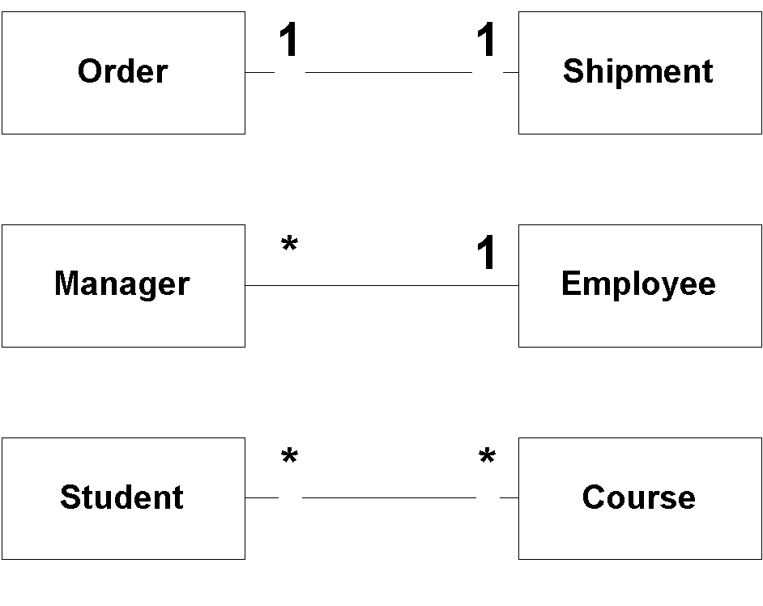
Figure 11.1 The Three Flavors of Cardinality
Let's look at how to code each type of relationship, for both BMP and CMP.
1:1 relationships
With a one-to-one relationship, each constituent can have at most one relationship with the other constituent. Examples of one-to-one relationships include:
- Person:Address
- Car:Windshield
- Order:Shipment
1:1 relationships are typically setup by a foreign key relationship in the database. Figure 11.2 shows a possible database setup.
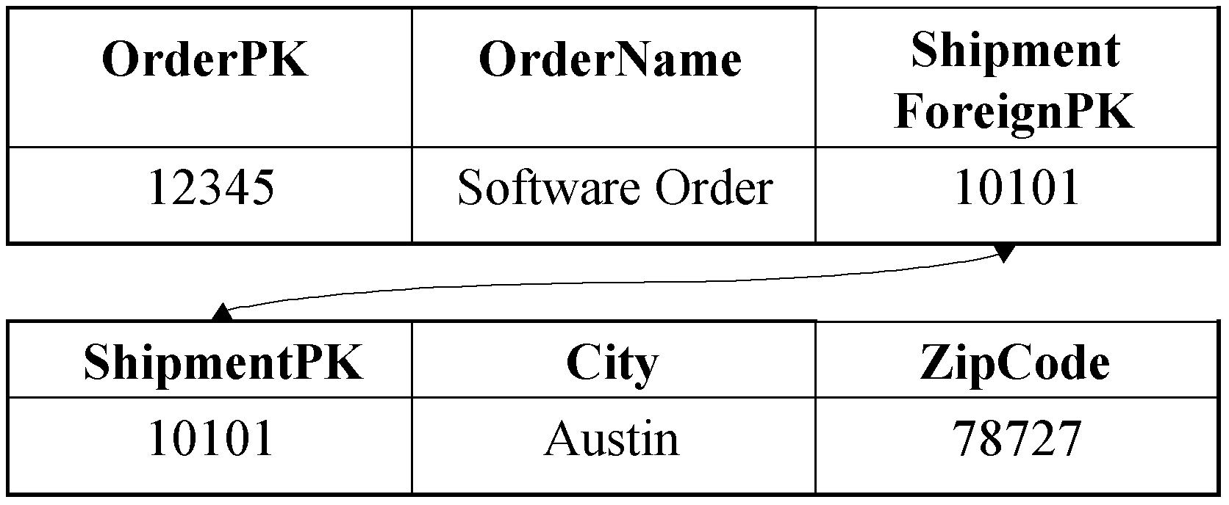
Figure 11.2 A possible one-to-one cardinality database schema
In Figure 11.2, the Order has a relationship with a Shipment. The Order table has a foreign key, which is the Shipment table's primary key. This foreign key is the link between the two tables. Note that this isn't the only way to setup a one-to-one relationship. You could also have the Shipment point to the Order.
Implementing 1:1 relationships using BMP
The following code shows how to implement a 1:1 relationship using BMP:
public class OrderBean implements EntityBean {
private String orderPK;
private String orderName;
private Shipment shipment; // EJB local object stub

public Shipment getShipment() { return shipment; }
public void setShipment(Shipment s) { this.shipment = s;}

...

public void ejbLoad() {
// 1: SQL SELECT Order. This also retrieves the
// shipment foreign key.
//
// 2: JNDI lookup of ShipmentHome
//
// 3: Call ShipmentHome.findByPrimaryKey(), passing
// in the shipment the foreign key
}
public void ejbStore() {
// 1: Call shipment.getPrimaryKey() to retrieve
// the Shipment foreign key
//
// 2: SQL UPDATE Order. This also stores the
// Shipment foreign key.
}
}
As with all BMP entity beans, we must define our SQL statements in our bean. See Chapter 5 for more on this. The special relationship management code is in bold.
The relationship management code is only necessary at the instant we transform our bean to-and-from relational data. It's necessary because we can't just persist a stub, like we can with our other fields (such as a String). If we did persist a stub, and (by some miracle) that worked, it would look like a bit-blob in the foreign key column. That bit-blob foreign key would not match up to the primary key in the Shipment table.
Here is an explanation for what's happening in our bean:
Our ejbLoad() method loads the database data for the Order, and part of that data is a foreign key to the Shipment. We need to transform that foreign key into a stub to a Shipment bean. Therefore we need to perform a JNDI lookup of the Shipment home, and then call a finder method, passing in the foreign key. This gives us a stub, and we can then call business methods on the Shipment.
Our ejbStore() method stores the database data for the Order, and part of that data is a foreign key to the Shipment. We need to transform the Shipment stub into a foreign key. Therefore we need to call getPrimaryKey() on the Shipment stub. This gives us our foreign key, and we can then perform the SQL.
Implementing 1:1 relationships using CMP
The following code shows how to implement that same 1:1 relationship using CMP:
public abstract class OrderBean implements EntityBean {
// no fields

public abstract Shipment getShipment();
public abstract void setShipment(Shipment s);

...

public void ejbLoad() {} // Empty
public void ejbStore() {} // Empty
}
As with all CMP entity beans, we define our get/set methods as abstract methods, and have no fields. The container implements these methods (and defines the fields) when the container subclasses our bean. See Chapter 6 for more on this.
What's exciting is that our ejbLoad() and ejbStore() methods are free of any scaffolding code. This is because the container generates all that scaffolding code for us. We do need to specify the relationship in the deployment descriptor, and we do so as follows:
<ejb-jar>

<enterprise-beans>
...
</enterprise-beans>

<relationships>

<!-- This declares a relationship -->
<ejb-relation>

<!-- The nickname we're giving this relationship -->
<ejb-relation-name>Order-Shipment</ejb-relation-name>

<!--
This declares the 1st half of the relationship
(the Order side)
-->
<ejb-relationship-role>

<!-- The nickname we're giving this half of the relationship -->
<ejb-relationship-role-name>
order-spawns-shipment
</ejb-relationship-role-name>

<!-- The Cardinality of this half of the relationship -->
<multiplicity>One</multiplicity>

<!--
The name of the bean corresponding to this
half of the relationship
-->
<role-source><ejb-name>Order</ejb-name></role-source>

<!--
Recall that a CMP entity bean has an abstract get/set
method for the relationship. We need to tell the
container which get/set method corresponds to this
relationship, so that the container can generate the
appropriate scaffolding code when subclassing our bean.
That is the purpose of this element, which is called the
container-managed relationship (CMR) field. The value
of the CMR field should be the name of your get/set
method, but without the get/set, and with a slight
change in capitalization. getShipment() becomes shipment.
-->
<cmr-field><cmr-field-name>shipment</cmr-field-name></cmr-field>
</ejb-relationship-role>

<!--
This declares the 2nd half of the relationship
(the Shipment side)
-->
<ejb-relationship-role>
<ejb-relationship-role-name>
shipment-fulfills-order
</ejb-relationship-role-name>
<multiplicity>One</multiplicity>
<role-source><ejb-name>Shipment</ejb-name></role-source>
</ejb-relationship-role>
</ejb-relation>
</relationships>

</ejb-jar>
The deployment descriptor should be self-explanatory. We have supplied enough information to the container that it's tools should be able to generate any necessary relationship code, such as the code we saw in the BMP example.
1:N relationships
A one-to-many relationship is one of the more common relationships you'll see in your object model. This is because often times, one-to-one relationships will be combined into a single data object, rather than having a relationship between two separate data objects. Examples of one-to-many relationships include:
- Order:LineItems
- Customer:Orders
- Company:Employees
1:N relationships are also typically setup by a foreign key relationship in the database. Figure 11.3 shows a possible database setup.
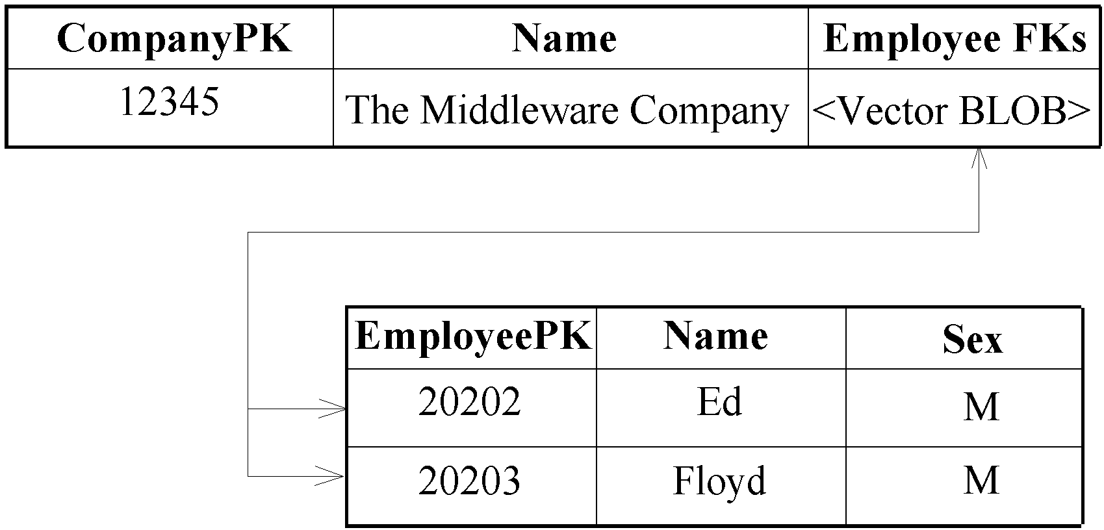
Figure 11.3 A possible one-to-many cardinality database schema
In Figure 11.3, the Company has a relationship with many Employees. The Company has a vector of line-item foreign keys, stored as a bit-blob in the database. We need a vector because we have a relationship with many Employees, not just one Employee.
The approach shown in Figure 11.3 is not ideal, because it's very nasty to deal with bit-blobs in the database. Queries and reporting become very challenging, as databases were not meant to handle relationships in this way. Figure 11.4 shows an alternative.
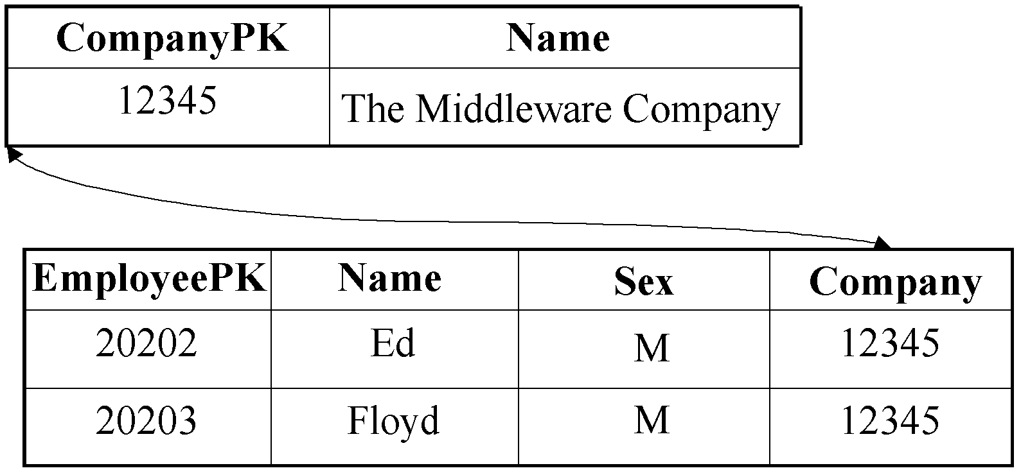
Figure 11.4 Another one-to-many cardinality database schema
In Figure 11.4, each Employee has a foreign key, which is the Company table's primary key. Thus the Employees are pointing back to their Company. This may seem backwards if we want to get from the Company to the Employees. It works, however, because the database doesn't care--it is a flat structure without a sense of direction. You can still construct queries that get from the Company to Employees.
Implementing 1:N relationships using BMP
The following code shows how to implement a 1:N relationship using BMP:
public class CompanyBean implements EntityBean {
private String companyPK;
private String companyName;
private Vector employees; // EJB object stubs

public Collection getEmployees() { return employees; }
public void setEmployees(Collection e) { this.employees = e;}

...

public void ejbLoad() {
// 1: SQL SELECT Company
// 2: JNDI lookup of EmployeeHome
// 3: Call EmployeeHome.findByCompany(companyPK)
}
public void ejbStore() {
// 2: SQL UPDATE Company
}
The code is explained as follows:
- A 1:N relationship has a Vector of stubs, rather than a single stub. Our get/set method gets and sets this Vector (a Vector is a Collection).
- Our ejbLoad() method is responsible for loading the Company state, as well as loading the relationships to Employees. How can we achieve this? Well, remember that the Employee table contains the foreign key relationships to the Company, not the reverse. Therefore it is natural for the Employee bean to access that relationship data, not the Company bean. Thus, we do not deal with foreign keys in our bean--we let the Employee bean deal with it. We do so by calling a finder method on the Employee local home object. That finder method locates each employee that is a member of this company, and returns a collection of stubs to us. Note that this does cause a second SQL statement to be executed.
- Our ejbStore() method is extremely straightforward. Since our ejbLoad() method is not responsible for dealing with foreign keys, neither is our ejbStore() method. It doesn't even know about the relationship. The Employee (not the Company) has an ejbStore() that persists foreign keys to the Company.
Note
If you're good at SQL, you might have noticed that in our example, if we really wanted to do so, we could load both the Company and the foreign keys for our Employee in one SQL statement. But this would not help us, because we would still need to transform those foreign keys into stubs. We'd need to call EmployeeHome.findByPrimaryKey() for each found key, which would generate even more SQL.
Implementing 1:N relationships using CMP
The following code shows how to implement a 1:N relationship using CMP:
public abstract class CompanyBean implements EntityBean {
// no fields

public abstract Collection getEmployees();
public abstract void setEmployees(Collection employees);

...

public void ejbLoad() {} // Empty
public void ejbStore() {} // Empty
}
Our ejbLoad() and ejbStore() methods are free of any scaffolding code. The relationships are specified in the deployment descriptor as follows:
<ejb-jar>
<enterprise-beans>
...
</enterprise-beans>

<relationships>
<ejb-relation>
<ejb-relation-name>Company-Employees</ejb-relation-name>
<ejb-relationship-role>
<ejb-relationship-role-name>
Company-Employs-Employees
</ejb-relationship-role-name>
<multiplicity>One</multiplicity>
<role-source><ejb-name>Company</ejb-name></role-source>
<!--
When you have a relationship with more than one object, you
can either use a java.util.Collection or a java.util.Set.
We need to identify which one we're using. How do you choose
between a Collection and a Set? A Collection can contain
duplicates, whereas a Set cannot. This needs to match up to
your bean's get/set methods.
-->
<cmr-field>
<cmr-field-name>lineItems</cmr-field-name>
<cmr-field-type>java.util.Collection</cmr-field-type>
</cmr-field>
</ejb-relationship-role>

<ejb-relationship-role>
<ejb-relationship-role-name>
Employees-WorkAt-Company
</ejb-relationship-role-name>
<multiplicity>Many</multiplicity>
<role-source><ejb-name>Employee</ejb-name></role-source>
</ejb-relationship-role>
</ejb-relation>
</relationships>
</ejb-jar>
As you can see, this is much simpler than BMP. If you understood the deployment descriptor for a 1:1 relationship described earlier in this chapter, then you should be able to grasp this one fairly easily.
Note
Relationships with CMP can be much higher performing than their BMP equivalents. With BMP, to load a 1:N relationship, we need to perform two SQL statements--we need to ejbLoad() the "1" side of the relationship, and then find() the "N" side of the relationship.
This is an inherent downside to BMP. With BMP, you are limited to performing SQL operations at the granularity of an entity bean. With CMP, if your container is good, you can optimize and tell the container to perform one gigantic SQL statement to load yourself and your relationships.
M:N relationships
A many-to-many relationship is not as common as a one-to-many relationship, but is still important. Examples of one-to-many relationships include:
- Student:Course
- Investor:MutualFund
- Stock:Portfolio
M:N relationships are typically setup by an association table in the database. An association table contains foreign keys to two other tables. Figure 11.5 shows a possible database setup.
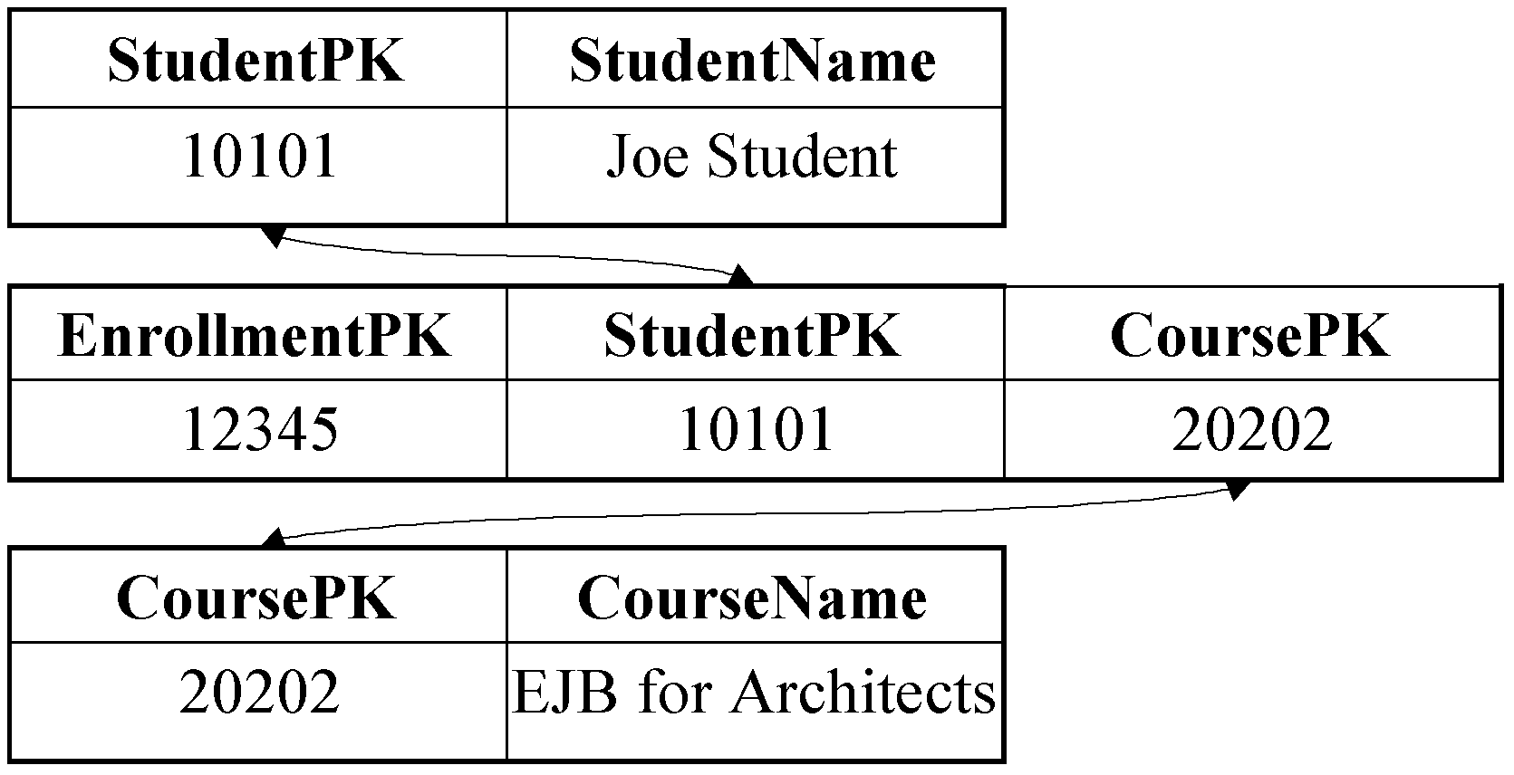
Figure 11.5 A possible many-to-many cardinality database schema
What's interesting about Figure 11.5 is that we've created a 3rd table, called an Enrollment table, which models the relationship between a Student and a Course. The alternative to an association table is for each half of the relationship to have a Vector of foreign keys to the other half, persisted as bit-blobs, which is very nasty to deal with.
Two choices when implementing M:N relationships
When you model an M:N relationship using entity beans, you have two choices:
Fake the M:N relationship by introducing a 3rd entity bean. Our Enrollment table could theoretically include other information as well, such as the date when the enrollment was made. It then makes sense to model the M:N relationship itself as an entity bean--an Enrollment bean. The Enrollment bean would map to the association table. This demonstrates a great modeling principle: when you have a many-to-many relationship, consider making the relationship itself into a first-class citizen. When you do this, you're introducing an intermediary. That intermediary has two 1:N relationships. Thus, we have effectively reduced the M:N relationship problem into two 1:N relationship problems!
Model the M:N relationship as a true M:N relationship. If you're just storing relationship information and that's all, you might not need to introduce a 3rd entity bean. In this case, you'd have only two entity beans, each representing half the relationship. Each entity beans would contain a Collection of the other entity bean. Each entity bean would be persisted to its own table, and each entity bean's Collection would be persisted to the relationships table. With BMP, you are in control of the JDBC, so you can map an entity bean to two tables very easily. With CMP, you're dependent on your container's persister.
We prefer the fake approach, because it keeps your entity beans pure and clean. The fewer relationships that you code into your entity beans, the more reusable your entity beans are in a variety of circumstances, and the less 'bloat' your entity beans incur. This approach also has the advantage that your entity bean and database being similar to one another, making mapping more straightforward.
What's cool, however, is that your EJB components can map to the database however you'd like. That is, both of the above approaches can map to association tables. This is because the database is completely unaware of how it's being represented in the middle tier. You can even switch back and forth between the fake and real approach if you'd like. And even if you're not using an association table but some other approach, you can still map your beans however you'd like, assuming you're good with JDBC (in the BMP case) or assuming your container vendor has a good persistence engine (in the CMP case).
Let's see how to model both fake and real M:N relationships with both BMP and CMP.
Implementing fake M:N relationships using BMP
The following code shows how to implement an M:N relationship as two 1:N relationships using BMP:
public class StudentBean implements EntityBean {
private String studentPK;
private String studentName;
...
public void ejbLoad() { // SQL SELECT Student }
public void ejbStore() { // SQL UPDATE Student }
}

public class CourseBean implements EntityBean {
private String coursePK;
private String courseName;
...
public void ejbLoad() { // SQL SELECT Course }
public void ejbStore() { // SQL UPDATE Course }
}

public class EnrollmentBean implements EntityBean {
private String enrollmentPK;
private Student student; // EJB local object stub
private Course course; // EJB local object stub

public Course getCourse() { return course; }
public void setCourse(Course c) { this.course = c;}

public Student getStudent() { return student; }
public void setStudent(Student s) { this.student = s; }

...

public void ejbLoad() {
// 1: SQL SELECT Enrollment. This loads both the
// Enrollment plus the foreign keys to Student
// and Course.
//
// 2: JNDI lookup of StudentHome, CourseHome
//
// 3: Call findByPrimaryKey() on both the Student
// and Course homes, passing the foreign keys
}
public void ejbStore() {
// 1: Call getPrimaryKey() on Student,Course. This
// gives us our foreign keys.
//
// 2: SQL UPDATE Enrollment
}
}
As usual, the relationship code is in bold. A brand-new entity bean, Enrollment, models the relationship between Student and Course. The Enrollment bean keeps a stub for a Course and a stub for a Student, and has get/set methods for clients to access those stubs. Then, at the point in which object/relational mapping occurs, we transform those stubs to-and-from their foreign key database representation.
Implementing fake M:N relationships using CMP
The following code shows how to implement a fake M:N relationship using CMP:
public abstract class StudentBean implements EntityBean {
// no fields
...
public void ejbLoad() {} // Empty
public void ejbStore() {} // Empty
}

public abstract class CourseBean implements EntityBean {
// no fields
...
public void ejbLoad() {} // Empty
public void ejbStore() {} // Empty
}

public abstract class EnrollmentBean implements EntityBean {
// no fields

public abstract Course getCourse();
public abstract void setCourse(Course c);

public abstract Student getStudent();
public abstract void setStudent(Student s);

...

public void ejbLoad() {} // Empty
public void ejbStore() {} // Empty
}
Our ejbLoad() and ejbStore() methods are free of any scaffolding code. The relationships are specified in the deployment descriptor as follows:
<ejb-jar>
<enterprise-beans>
...
</enterprise-beans>

<relationships>
<ejb-relation>
<ejb-relation-name>Enrollment-Student</ejb-relation-name>
<ejb-relationship-role>
<ejb-relationship-role-name>
Enrollments-AreRegisteredBy-Student
</ejb-relationship-role-name>
<multiplicity>Many</multiplicity>
<role-source><ejb-name>Enrollment</ejb-name></role-source>
<cmr-field><cmr-field-name>student</cmr-field-name></cmr-field>
</ejb-relationship-role>

<ejb-relationship-role>
<ejb-relationship-role-name>
Student-Has-Enrollments
</ejb-relationship-role-name>
<multiplicity>One</multiplicity>
<role-source><ejb-name>Student</ejb-name></role-source>
</ejb-relationship-role>
</ejb-relation>

<ejb-relation>
<ejb-relation-name>Enrollment-Course</ejb-relation-name>
<ejb-relationship-role>
<ejb-relationship-role-name>
Enrollments-AreRegistrationsFor-Course
</ejb-relationship-role-name>
<multiplicity>Many</multiplicity>
<role-source><ejb-name>Enrollment</ejb-name></role-source>
<cmr-field><cmr-field-name>course</cmr-field-name></cmr-field>
</ejb-relationship-role>

<ejb-relationship-role>
<ejb-relationship-role-name>
Course-Has-Enrollments
</ejb-relationship-role-name>
<multiplicity>One</multiplicity>
<role-source><ejb-name>Course</ejb-name></role-source>
</ejb-relationship-role>
</ejb-relation>
</relationships>
</ejb-jar>
As you can see from the deployment descriptor above, we model our fake M:N relationship as two N:1 relationships (one for each bean in the relationship). An N:1 relationship is conceptually the same as a 1:N relationship, and we already learned about how to model a 1:N relationship with CMP earlier.
Implementing true M:N relationships using BMP
The following code shows how to implement a true M:N relationship using BMP:
public class StudentBean implements EntityBean {
private String studentPK;
private String name;
private Vector courses; // EJB object stubs

public Collection getCourses() { return courses; }
public void setCourses(Collection c) { this.courses = c;}

...

public void ejbLoad() {
// 1: SQL SELECT Student
// 2: JNDI lookup of CourseHome
// 3: Call CourseHome.findByStudent(studentPK)
}
public void ejbStore() {
// SQL UPDATE Student
}

public class Course implements EntityBean {
private String coursePK;
private String name;
private Vector students; // EJB object stubs

public Collection getStudents() { return students; }
public void setStudents(Collection s) { this.students = s;}

...

public void ejbLoad() {
// 1: SQL SELECT Course
// 2: JNDI lookup of StudentHome
// 3: Call StudentHome.findByCourse(coursePK)
}
public void ejbStore() {
// SQL UPDATE Course
}
The relationship code is in bold. As you can see, all we've done to model a true M:N relationship is to code a 1:N relationship for each bean in the relationship. This is similar code to the code presented when we learned about 1:N relationships.
Implementing true M:N relationships using CMP
The following code shows how to implement a true M:N relationship using CMP:
public abstract class StudentBean implements EntityBean {
// no fields

public abstract Collection getCourses();
public abstract void setCourses(Collection courses);

...

public void ejbLoad() {} // Empty
public void ejbStore() {} // Empty
}

public abstract class CourseBean implements EntityBean {
// no fields

public abstract Collection getStudents();
public abstract void setStudents(Collection students);

...

public void ejbLoad() {} // Empty
public void ejbStore() {} // Empty
}
Our ejbLoad() and ejbStore() methods are free of any scaffolding code. The relationships are specified in the deployment descriptor as follows:
<ejb-jar>
<enterprise-beans>
...
</enterprise-beans>

<relationships>
<ejb-relation>
<ejb-relation-name>Student-Course</ejb-relation-name>
<ejb-relationship-role>
<ejb-relationship-role-name>
Students-EnrollIn-Courses
</ejb-relationship-role-name>
<multiplicity>Many</multiplicity>
<role-source><ejb-name>Student</ejb-name></role-source>
<cmr-field>
<cmr-field-name>courses</cmr-field-name>
<cmr-field-type>java.util.Collection</cmr-field-type>
</cmr-field>
</ejb-relationship-role>

<ejb-relationship-role>
<ejb-relationship-role-name>
Courses-HaveEnrolled-Students
</ejb-relationship-role-name>
<multiplicity>Many</multiplicity>
<role-source><ejb-name>Course</ejb-name></role-source>
<cmr-field>
<cmr-field-name>students</cmr-field-name>
<cmr-field-type>java.util.Collection</cmr-field-type>
</cmr-field>
</ejb-relationship-role>
</ejb-relation>
</relationships>
</ejb-jar>
As you can see, modeling a true M:N relationship using CMP is extremely straightforward. We just use the words "Many" on each half of the relationship, and state that each half of the relationship has a Collection of the other half.
If you've made it this far, congratulations--this concludes our cardinality discussion! Let's move on to directionality.
Directionality
The directionality of a relationship specifies the direction in which you can navigate a relationship. There are two flavors of directionality:
Bidirectional. You can get from entity A to entity B, and can also get from entity B to entity A.
Unidirectional. You can get from entity A to entity B, but cannot get from entity B to entity A
Directionality applies to all cardinalities (1:1, 1:N, and M:N). Directionality and cardinality are orthogonal and complementary concepts. You can mix and match them however you'd like.
Let's use our 1:1 relationship example of an Order and a Shipment to help us figure out directionality.
Implementing Directionality with BMP
The following code is a bi-directional relationship, with the key information in bold:
public class OrderBean implements EntityBean {
private String orderPK;
private String orderName;

// EJB local object stub, must be stored/loaded
private Shipment shipment;

public Shipment getShipment() { return shipment; }
public void setShipment(Shipment s) { this.shipment = s; }

...
}

public class ShipmentBean implements EntityBean {
private String shipmentPK;
private String shipmentName;

// EJB local object stub, must be stored/loaded
private Order order;

public Order getOrder() { return order; }
public void setOrder(Order o) { this.order = o; }

...
}
As you can see, in a bi-directional relationship, each bean in the relationship has a field pointing to the other bean, along with a get/set method.
By way of comparison, with a unidirectional relationship, we don't allow the user to get from the second bean to the first bean:
public class OrderBean implements EntityBean {
private String orderPK;
private String orderName;

// EJB local object stub, must be stored/loaded
private Shipment shipment;

public Shipment getShipment() { return shipment; }
public void setShipment(Shipment s) { this.shipment = s; }

...
}

public class ShipmentBean implements EntityBean {
private String shipmentPK;
private String shipmentName;

// No Order stub, no Order get/set method

...
}
Implementing Directionality with CMP
The following is a bi-directional CMP relationship:
public abstract class OrderBean implements EntityBean {
// no fields

public abstract Shipment getShipment();
public abstract void setShipment(Shipment s);

...

public void ejbLoad() {} // Empty
public void ejbStore() {} // Empty
}

public abstract class ShipmentBean implements EntityBean {
// no fields

public abstract Order getOrder();
public abstract void setOrder(Order o);

...

public void ejbLoad() {} // Empty
public void ejbStore() {} // Empty
}
As you can see, in a bi-directional CMP relationship, each bean in the relationship has a pair of abstract get/set methods pointing to the other bean. We need to tell the container that these get/set methods are special relationship methods so that the container can generate relationship code. Here is the deployment descriptor that achieve this:
<ejb-jar>

<enterprise-beans>
...
</enterprise-beans>

<relationships>
<ejb-relation>
<ejb-relation-name>Order-Shipment</ejb-relation-name>
<ejb-relationship-role>
<ejb-relationship-role-name>
order-spawns-shipment
</ejb-relationship-role-name>
<multiplicity>One</multiplicity>
<role-source><ejb-name>Order</ejb-name></role-source>
<cmr-field><cmr-field-name>shipment</cmr-field-name></cmr-field>
</ejb-relationship-role>

<ejb-relationship-role>
<ejb-relationship-role-name>
shipment-fulfills-order
</ejb-relationship-role-name>
<multiplicity>One</multiplicity>
<role-source><ejb-name>Shipment</ejb-name></role-source>
<cmr-field><cmr-field-name>order</cmr-field-name></cmr-field>
</ejb-relationship-role>
</ejb-relation>
</relationships>

</ejb-jar>
In the deployment descriptor, we setup two container-managed relationship (CMR) fields: one for each bean's abstract get/set method pair that points to the other bean.
If we were to make this into a unidirectional relationship, we would simply get rid of an abstract get/set method pair, along with its corresponding CMR field.
Directionality may not map to database schemas
Note that directionality in entity beans may not correspond to the inherent 'directionality' of the database schema. An entity bean could provide for directionality even though the database does not very easily, and vice versa. For example, here is a normalized database schema for a Person:Address relationship:
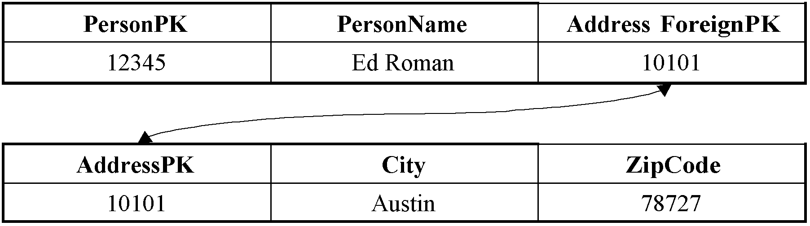
Figure 11.6 A normalized schema
And here is a denormalized schema:
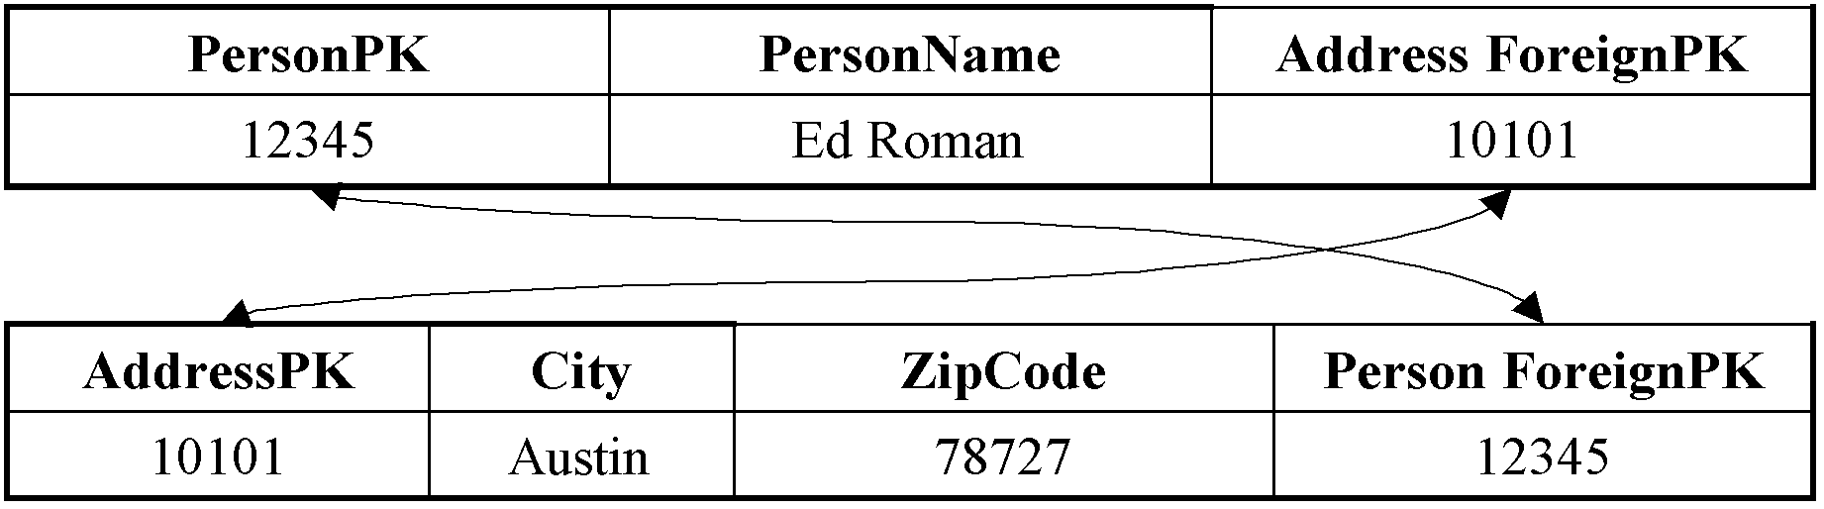
Figure 11.7 A denormalized schema
Both these schemas give us enough information to derive relationship information. You can, if you choose to do so, map entity beans to both these schemas and use bi-directional relationships. The difference is the denormalized schema allows for more efficient SQL. That is the classic Computer Science space-time tradeoff. If you denormalize the database then you are wasting space and increasing maintenance problems, but you are gaining speed.
Bidirectional or Unidirectional?
So how do you choose between bi-directional and unidirectional relationships? Here are some questions to ask yourself:
- Should each bean know about the other bean? Would that hamper reuse?
- From the client's perspective, does it make intuitive sense to navigate the relationship from the direction in question?
- Is the database mapping of stubs to foreign keys straightforward, or does adding directionality result in mapping to multiple tables, resulting in inadequate performance?
Lazy Loading
All the relationship code we've seen so far makes a big assumption: Whenever an entity bean is loaded, all of the other entity beans that it has a relationship with are also loaded. This is called aggressive loading. We saw this, for example, with our Order:Shipment relationship at the beginning of this chapter. The Order bean looked up the Shipment bean in the Order bean's ejbLoad() method.
Aggressive loading is nice because you can load all database data in a single transaction. However, it does have its downsides. Aggressive loading could lead to loading a very large entity bean graph, and you may not need that entire graph.
Lazy loading means to only load related beans when you need to access those beans. For example, with the Order:Shipment relationship using BMP that we presented at the beginning of this chapter, we would rewrite the code to lazy-load as follows:
public class OrderBean implements EntityBean {
private String orderPK;
private String orderName;

private String shipmentFK; // Foreign key to shipment
private Shipment shipment; // EJB local object stub

public void ejbLoad() {
// 1: SQL SELECT Order, loading the shipment foreign key
// 2: Set shipmentFK field to the loaded key
}

public Shipment getShipment() {
// 1: JNDI lookup of ShipmentHome
// 2: Call ShipmentHome.findByPrimaryKey(shipmentFK)
return shipment;
}

...

}
In the above code, we are looking up the shipment just in time when the client calls getShipment(), rather than in ejbLoad(). ejbLoad() merely locates the appropriate foreign key, which getShipment() uses.
With CMP, lazy-loading happens automatically behind-the-scenes. You are, however, reliant on container-specific flags to enable lazy-loading. Most major containers support this, so check your container documentation.
Design Tip: Aggressively Load in One Direction Only for Many-to-Many Relationships
With many-to-many relationships you need to be very careful with how aggressively you load your entity bean graph. For example assume that Larry lives at addresses A, B, and C; Curly at C and D; Moe at C and E; and E is a commune with 37 people living in it. Larry, Curly, Moe, and everyone in the commune is a customer of ours. If we cascade the load across the relationship in both directions when we read in Larry we would retrieve at least five address objects and forty customer objects, not to mention any other addresses that the commune people also live in and any customers and their addresses that those retrievals would then cascade to. The same problem arises if we were to cascade the deletion in both directions too. Instead what we need to do is cascade the retrieval and deletion in one direction, or be incredibly smart about how we cascade in both directions. Unless your entity bean graph is small, we recommend you use lazy-loading for at least one direction of the relationship.
Aggregation vs. Composition and Cascading Deletes
When you have a relationship between two entity beans, you need to think about whether that relationship is an aggregation or a composition relationship.
An aggregation relationship is a uses relationship. For example, Students use Courses. If you delete a Student, you don't delete the Courses the student is registered in, because other students are using that Course. Similarly, if you delete a Course, you don't murder a Student!
A composition relationship is an is-assembled-of relationship. For example, Orders are assembled of Line Items. Deleting an Order deletes all Line Items. Line Items shouldn't be around if their parent Order is gone.
Once you've figured out whether your relationship is an aggregation or composition, you then need to write your entity beans so that they model the semantics you desire. This all boils down to a concept called a cascading delete. An aggregation relationship does not cause a cascading delete, whereas a composition relationship does.
With BMP, you implement a cascading delete manually in your ejbRemove() method. For example, an Order bean's ejbRemove() method would not only perform a SQL DELETE of the Order, but it would also call the Shipment bean's ejbRemove() method as well:
public class OrderBean implements EntityBean {
private String orderPK;
private String orderName;
private Shipment shipment; // EJB local object stub

public Shipment getShipment() { return shipment; }
public void setShipment(Shipment s) { this.shipment = s;}

...

public void ejbRemove() {
// 1: SQL DELETE Order
// 2: shipment.remove();
}
}
With CMP, the container generates cascading delete code for you. If you have a composition relationship, you just need to setup a <cascade-delete/> tag in the deployment descriptor, such as follows:
<ejb-jar>

<enterprise-beans>
...
</enterprise-beans>

<relationships>
<ejb-relation>
<ejb-relation-name>Order-Shipment</ejb-relation-name>
<ejb-relationship-role>
<ejb-relationship-role-name>
order-spawns-shipment
</ejb-relationship-role-name>
<multiplicity>One</multiplicity>
<role-source><ejb-name>Order</ejb-name></role-source>
<cmr-field><cmr-field-name>shipment</cmr-field-name></cmr-field>
</ejb-relationship-role>

<ejb-relationship-role>
<ejb-relationship-role-name>
shipment-fulfills-order
</ejb-relationship-role-name>
<multiplicity>One</multiplicity>
<cascade-delete/>
<role-source><ejb-name>Shipment</ejb-name></role-source>
<cmr-field><cmr-field-name>order</cmr-field-name></cmr-field>
</ejb-relationship-role>
</ejb-relation>
</relationships>

</ejb-jar>
If you have an aggregation relationship, you just leave the <cascade-delete/> tag out.
Relationships and EJB-QL
When setting up CMP relationships, you can also setup special queries using the EJB Query Language (EJB-QL), which we briefly described in Chapter 6 and fully explain in Appendix C. The following is relevant to our discussion and is excerpted from Appendix C:
The big difference between EJB-QL and SQL is that EJB-QL allows you to traverse relationships between entity beans using a dot-notation. For example:
SELECT o.customer
FROM Order o
In the above EJB-QL, we are returning all customers that have placed orders. We are navigating from the order entity bean to the customer entity bean easily using a dot-notation. This is quite seamless.
What's exciting about this notation is that bean providers don't need to know about tables or columns, rather they merely need to understand the relationships between the entity beans that they've authored. The container will handle the traversal of relationships for us because we declare our entity beans in the same deployment descriptor and ejb-jar file, empowering the container to manage all of our beans and thus understand their relationships.
In fact, you can traverse more than one relationship. That relationship can involve container-managed relationship fields and container-managed persistent fields. For example:
SELECT o.customer.address.homePhoneNumber
FROM Order o
The restriction on this type of recursive relationship traversal is that you are limited by the navigatability of the relationships that you define in the deployment descriptor. For example, let's say that in the deployment descriptor, you declare that orders have a 1-to-many relationship with line-items, but you do not define the reverse many-to-1 relationship that line-items have with orders. When performing EJB-QL, you can then get from orders to line-items, but not from line-items to orders.
Recursive Relationships
A recursive relationship is one in which an entity bean instance has a relationship with another instance of the same entity bean class, such as what's shown in Figure 11.8.
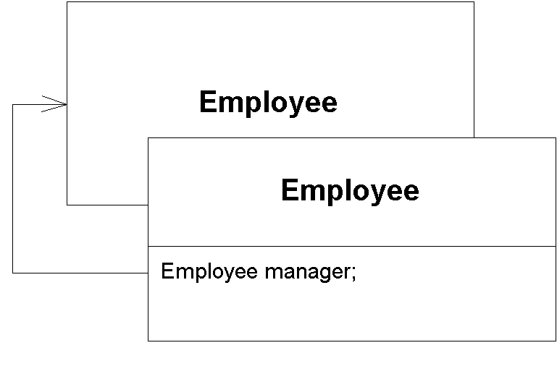
Figure 11.8 A recursive relationship
Figure 11.8 shows an Employee:Manager relationship. All that this means is: our Employee entity bean has a relationship with another Employee entity bean.
As you would expect, recursive relationships are implemented exactly as non-recursive relationships. All the principles we learned earlier apply, and nothing is new. We just happen to have a relationship with an instance of an entity bean that uses the same class.
Circular Relationships
A circular relationship is similar to a recursive relationship except that instead of involving a single entity bean, it involves several. For example, Figure 11.9 depicts a circular relationship.
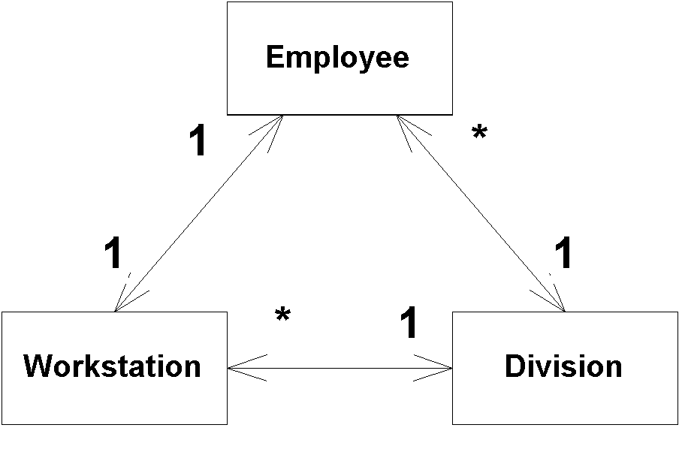
Figure 11.9 A circular relationship
The following relationships exist:
- Employees work in a division.
- A division owns one or more workstations.
- An employee has a workstation.
The problem with circular relationships is that if your beans automatically find each other, then you will get into an endless circle of finding. The same problem exists for cascading deletes.
So how do you implement circular relationships between EJBs appropriately? You have several implementation strategies:
- Some containers allow you optimize performance and load an entity bean at the same time that it's found. This is where the circularity issue stems from, because it's the ejbLoad() method that performs the cascading find. By not loading an entity bean when it's found, there is no cascading 'find' operation.
- Break the circular relationship by removing one of the relationships altogether. This is a harsh approach to resolving the problem.
- Break the circular relationships within your model by making one or more relationships unidirectional, effectively breaking the circle in both directions. This isn’t always an option for you because your requirements may not permit it.
- Use lazy-loading rather than aggressive loading, and do not use cascading deletes.
- Choose a persister that detects circular relationships. Many persistence administration tools will automatically detect and warn you of circular relationships when you define them. This allows you to prevent the problem before it occurs.
Referential Integrity
Referential integrity is the assurance that a reference from one entity to another entity is valid. For example:
- Let's say a Company, Department, and Position each have relationships with an Employee. If the Employee is removed, then all references to it must also be removed, or else your system must not allow the removal.
- Let's say an Order has a 1:N relationship with a Line Item. When someone adds a second Order to an Order Line Item, they are trying to change a 1:N relationship into an M:N relationship. We must therefore break the Line Item's relationship with the original Order, so that we maintain our intended 1:N semantics.
Referential integrity issues arise in both the database (keeping foreign keys correct) and in the application server (keeping stubs correct). So how do you ensure referential integrity within your EJB applications? You have three fundamental options:
- Enforce referential integrity within your database with triggers. For example, you could write a trigger that fires off when an Employee is deleted. This trigger would delete the relationships the Employee had with other database tables to preserve referential integrity.
- Enforce referential integrity within your database with stored procedures. Your EJB component would call these stored procedures to perform database operations, and the stored procedures would be responsible for preserving referential integrity.
- Enforce referential integrity within EJB components.
Implementing referential integrity in your database has the advantage that other non-EJB applications can take advantage of it, your database being the lowest common denominator within your organization. Relational databases implement triggers for exactly this purpose, and most data modeling tools support the generation of trigger code to simplify this effort for you. The drawback of implementing logic in your database is that it increases the processing burden on your database server(s), running the risk that your database becomes a bottleneck to your application. You can also take a hybrid approach to implementing referential integrity, where your EJBs handle the referential integrity for some entities and your database for others. You might decide to take the “pure” approach with any objects persisted to your own private database whereas with the shared database allow it to ensure referential integrity of the objects stored there.
Of all these options, we do believe that the EJB approach is the cleanest and the easiest to maintain over the long-term, because your EJB layer encapsulates all relationships. Here is how you do it with EJB:
With BMP you need to take care of referential integrity on your own. You do so by manually breaking old relationships. If someone tries to assign a second Order to your Line Item, then your Line Item bean should call the Order bean, and tell the Order bean to remove you from its list of Line Items.
With CMP the container will automatically handle referential integrity for you. You should never have to worry about the above issues. This is one neat feature the container provides that makes CMP a very compelling value proposition.
Note that it's not quite this simple. To complicate matters, you might have a farm of EJB application servers, and your component might exist simultaneously on several machines. Furthermore, if you have other applications accessing your database then it is possible that they too have representations of your data in their memory as well. The good news is that transactions (see Chapter 12) solve this problem. For example, when you delete an Employee and also delete the relationships it has with other entities within a transaction, either all or none of the deletions would occur, preserving referential integrity.
Where You Implement Referential Integrity is Often Out of Your Hands
Writing code to enforce referential integrity in your EJB components instead of your database only works when all of your applications are written this way (and hopefully they share a common code base). This situation, however, is rarely the case. Instead many organizations are in the position that some of their applications, often most, are written assuming that the database(s) will handle referential integrity. This is clearly an inappropriate layering of these applications because business logic is now implemented on several disparate architectural tiers, making the applications less robust. However, it is a reality that many EJB developers must accept – some of their business logic will be implemented in the database, perhaps through triggers or through Java objects implemented within the database.
Relationships, referential integrity, and client code
Throughout this chapter, we've seen lots of fascinating relationships. Many of those relationships involved collections. For example, here is our Company:Employee 1:N CMP relationship again.
public abstract class CompanyBean implements EntityBean {
// no fields

public abstract Collection getEmployees();
public abstract void setEmployees(Collection employees);

...

public void ejbLoad() {} // Empty
public void ejbStore() {} // Empty
}
This code has methods to get/set entire Collections of employees. But what's interesting is there's no API for clients to perform operations on individual employees.
This is where the Collection comes into play. By using the Collection from client code, you can modify the contents of a 1:N relationship. For example:
// Lookup local home objects
Context ctx = new InitialContext(...);
CompanyHome home = (CompanyHome) PortableRemoteObject.narrow(
ctx.lookup("CompanyHome"), CompanyHome.class);
CompanyHome home = (Employee) PortableRemoteObject.narrow(
ctx.lookup("EmployeeHome"), EmployeeHome.class);

// Make a new employee
Employee employeeA = employeeHome.create("Ed Roman");

// Find a company
Company company = home.findByPrimaryKey("The Middleware Company");
Collection employees = company.getEmployees();

// Add the employee to the company.
// This demonstrates the add() Collection API method
employees.add(employeeA);

// Look at each employee in the company.
// This demonstrates using iterators to loop through collections
Iterator i = employees.iterator();
while (i.hasNext()) {
Employee emp = (Employee) i.next();
System.out.println(emp.getName());
}

// Remove the employee from the company.
// This demonstrates the remove() Collection API
employees.add(employeeA);
Since we're using local interfaces, the collection that the client modifies is the same as the collection inside the bean. This is because the get/set methods pass the collection by-reference rather than by-value. Thus, when the client modifies the contents of the collection, he is actually changing the bean's relationships.
The container is responsible for providing an implementation of the Collection interface. This needs to be a "smart" collection that understands how to preserve referential integrity for you behind-the-scenes.
Note
Be careful when using iterators and relationships. If you want to modify a relationship while an iterator is at-work, you should only use the java.util.Iterator.remove() method. This is because adding or removing elements from a collection while the iterator is in progress will throw off the iterator.
Table 11.1 lists the effects that client operations have on referential integrity. Note that for the 1:N and M:N rows on the table, we are performing operations on collections, and are using the collections API for operations such as add() and remove().
Just to get you thinking...@@@COMP: Give these notes a special common look@@@
Try to only look at the first 3 columns, and see if you can guess what the 4th column should be.
Table 11.1 Client Operations and Referential Integrity
Situation | Original Relationships | Operation | New Relationships
1:1 Relationship  Order:Shipment | orderA-shipmentA  orderB-shipmentB | orderA.setShipment(  orderB.getShipment()); | OrderA-ShipmentB  OrderB-Empty Collection
1:N Relationship Company:Employee | companyA-employeeA  companyA-employeeB  companyB-employeeC  companyB-employeeD | companyA.setEmployees(  companyB.getEmployees()); | companyA-employeeA  companyA-employeeB  companyA-employeeC  companyA-employeeD  companyB-Empty Collection
1:N Relationship Company:Employee | companyA-employeeA  companyA-employeeB  companyB-employeeC  companyB-employeeD | employeeA.setCompany(  employeeC.getCompany()); | companyB-employeeA  companyA-employeeB  companyB-employeeC  companyB-employeeD
1:N Relationship Company:Employee | companyA-employeeA  companyA-employeeB  companyB-employeeC  companyB-employeeD | companyB.getEmployees().  add(employeeA); | companyB-employeeA  companyA-employeeB  companyB-employeeC  companyB-employeeD
1:N Relationship Company:Employee | companyA-employeeA  companyA-employeeB  companyB-employeeC  companyB-employeeD | companyA.getEmployees().  remove(employeeA); | NULL-employeeA  companyA-employeeB  companyB-employeeC  companyB-employeeD
M:N Relationship  Student:Course | studentA-courseA  studentA-courseB  studentB-courseB  studentB-courseC | studentA.setCourses(  studentB.getCourses()); | studentA-courseB  studentA-courseC  studentB-courseB  studentB-courseC
M:N Relationship  Student:Course | studentA-courseA  studentA-courseB  studentB-courseB  studentB-courseC | studentA.getCourses().  add(courseC); | studentA-courseA  studentA-courseB  studentA-courseC  studentB-courseB  studentB-courseC
M:N Relationship  Student:Course | studentA-courseA  studentA-courseB  studentB-courseB  studentB-courseC | studentA.getCourses().  remove(courseB); | studentA-courseA  studentB-courseB  studentB-courseC
Summary
Still with us? Fantastic! Go ahead and pat yourself on the back, because you've achieved a great deal in this chapter. You learned about cardinality, directionality, referential integrity, cascading deletes, recursive relationships, circular relationships, lazily-loaded relationships, and how to control relationships from client code. You also saw how to implement each of the above topics using both CMP and BMP.
By reading this relationships chapter, you've solidified your knowledge of relationships and should now be well-prepared to go ahead and implement relationships in your own deployments. For concrete examples without pseudocode that you can use as a basis for your own deployments, see the book's accompanying source code.

